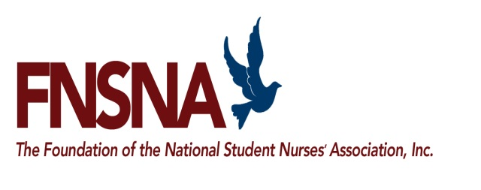

Student Name: ______________________________

Student ID: _________________________________
Dean/Director Certification

This form must be completed by the Dean/Director/Chair or Faculty Advisor at the school that you are attending. Print out this form and submit it to the proper representative for completion.

The above named student is applying for a Promise of Nursing Regional Faculty Fellowship. This program is for baccalaureate prepared nurses who are looking to pursue a career in nursing education. Please complete the following information:

Is the student preparing for the nurse educator role? Yes No

What is the student’s GPA (on a 4.0 scale)? _______________

Current Status:

Expected Date of Graduation: ___________________
(mm/yy)

- If doctoral student, expected Date of Dissertation Proposal: ___________________
(mm/yy)

Expected Date of Dissertation Defense: ___________________
(mm/yy)

- If DNP Student, Capstone Project Completion Date: ___________________
(mm/yy)

Please write a brief state including, but not limited to, the student’s academic standing, expectation to succeed in the program; scholarship and professional activities, attributes that support the student’s anticipated career goal to become a nurse educator. If necessary, please use another page.

I hereby certify that I have answered the questions to the best of my knowledge and recommend this student for consideration or the Promise of Nursing Regional Faculty Fellowship.

Name: ___________________________________ Title: _________________________________________

Email: ___________________________________ Date: _________________________________________

