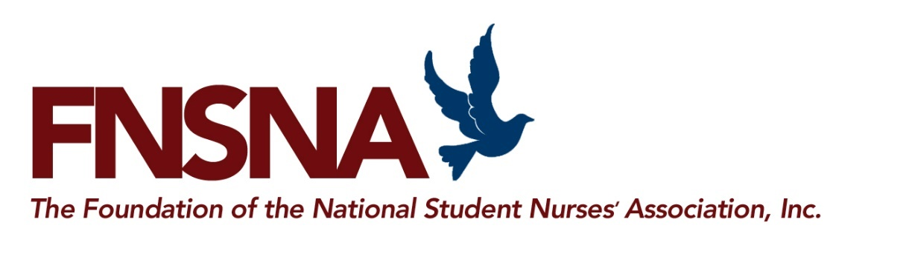
www.forevernursing.org fnsna@forevernursing.org

2020 SCHOLARSHIP PROGRAM IS NO LONGER AVAILABLE

The 2021-2022 scholarship application will be available in September 2020 on
www.forevernursing.org

WHO IS ELIGIBLE?
- Students currently enrollment and matriculated in a state-approved nursing program leading to an associate degree, baccalaureate, diploma, generic pre-licensure doctorate or generic pre-licensure master’s degree; or enrolled in an RN to BSN completion, RN to MSN completion, or LPN/LVN to RN program;
Matriculation means the student has applied to and has been admitted into a state approved nursing program.
(Students in a 16-18 month accelerated program please contact the FNSNA for more details for eligibility)
- Pre-nursing students taking courses to prepare for matriculation into a nursing program;
- Attending classes and taking no less than six (6) credits per semester.
- Involvement in student nursing organizations and/or community health activities;
- Document academic achievement;
- Establish financial need;
- U.S. Citizen or Alien with U.S. Permanent Resident Status/Alien Registration Number;
- High school students are not eligible to apply;
- Funds are not available for graduate study unless it is for a first degree in nursing.

HOW MUCH MONEY IS AVAILABLE?
The NSNA Foundation awards over $250,000 annually in the general scholarship and promise of nursing programs. Scholarship funding is up to $7,500.

Promise of Nursing Scholarships are available in selected regions of the US. Your school/college of nursing’s zip code determines eligibility for this new scholarship program which is supported by fund-raising events sponsored by Johnson & Johnson. Funds for this scholarship are supported by contributors in selected regions.

WHAT CRITERIA ARE USED FOR SELECTION?
The scholarships are based on academic achievement, financial need, and involvement in nursing
student organizations and community activities related to health care. Additional criteria may be required by some sponsors.

WHEN WILL THE SCHOLARSHIPS BE AWARDED?
Scholarships are awarded in the spring of 2021 for use in summer school 2021 and the 2021 – 2022
academic year.

WHO CHOOSES THE RECIPIENTS?
A committee of faculty and students is appointed by the NSNA Foundation to select recipients.

WHEN IS THE APPLICATION AVAILABLE? The 2021-2022 online scholarship application will be available in September 2020.

DEADLINE FOR COMPLETED APPLICATIONS?
Applications must be submitted online by January 2021.

WHAT DOCUMENTS ARE REQUIRED WITH THE APPLICATION?
All applicants must submit a copy of their recent nursing school and college transcripts, or grade report. NSNA members must submit proof of their membership. Registered nurses in baccalaureate programs and licensed practical/vocational nurses in programs leading to registered nurse licensure must submit a copy of their license to be considered for the Career Mobility Scholarships. Complete details are in the online application.

