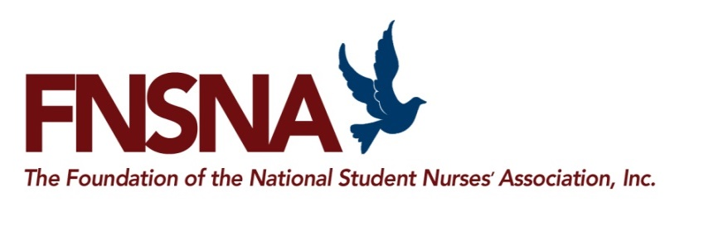

Foundation of NSNA Scholarship Program

SPONSOR REPLY FORM
Return to Lauren Sperle via E-mail Lauren@nsna.org

When completing this form please use the TAB key not the ENTER key

Sponsor Organization
As you wish it to appear in publicity materials

Contact Name

Title

Address

City State Zip

Email Phone#

2020 Scholarship Program—Yes, we will participate!

Number of Scholarships Amount $ Administrative Fee $
(Minimum scholarship amount is $2,500 with an additional 10% administration fee)
E-Signature Date:

Thank you for supporting our future RNs!

